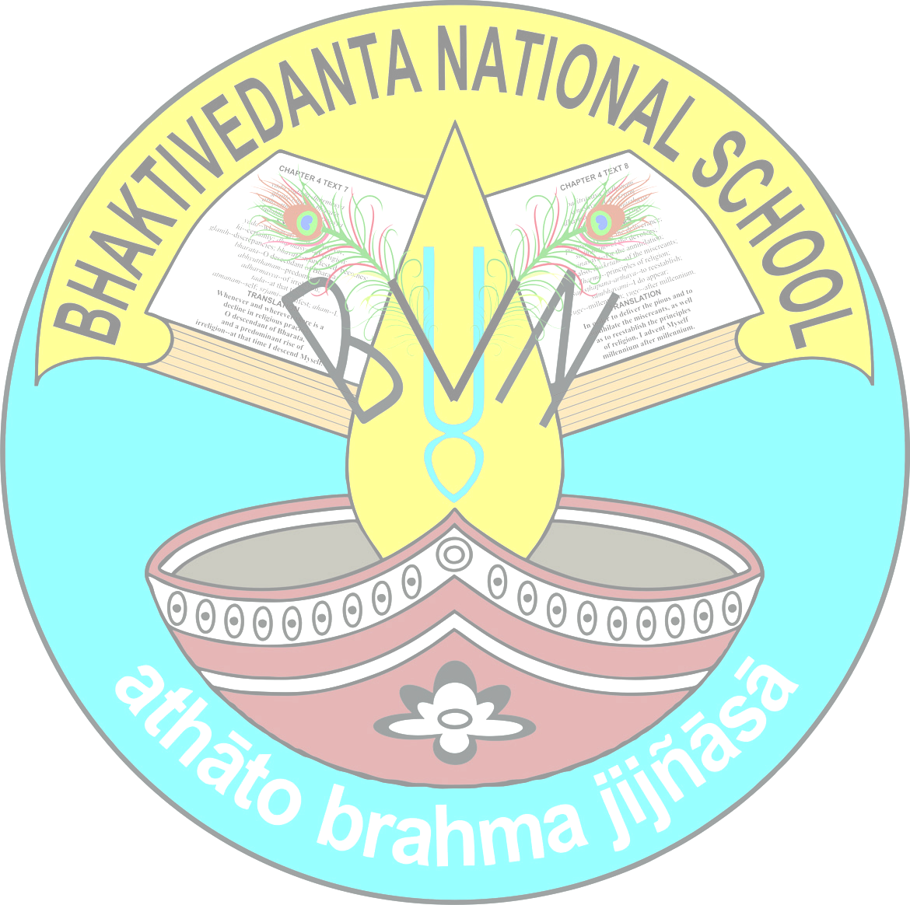

BHAKTIVEDANTA NATIONAL SCHOOL
SRI MAYAPUR, NADIA, 741313
2026-27
STD - VI

SUBJECT: ENGLISH LANGUAGE
EXAM | BOOK NAME: Essentials of English Grammar and Composition | PROJECT/ACTIVITY
EXAM | CHAPTER NUMBER AND NAME | PROJECT/ACTIVITY
Pre mid /CT1 | Ch-1 (The Sentence ),  Ch-2 (Subject amd Predicate),  Ch-3 (Nouns),  Ch-4(Nouns:Number),  Ch-5(Nouns:Gender),  Ch-6(Nouns:Case ),  Ch-7(Adjectives ),  Ch-8(Adjectives:Degrees of Comparison ), Ch-9( Articles),  Ch-10( Pronouns),  Ch-32(Synonyms and Antonyms), Ch-37(Writing Messages),  Ch-39( Paragraph Writing) | Pronouns swap activity
Mid Term/CT2 | Ch-11(Personal Pronouns:Number, Gender and Case),Ch-12(Verbs), Ch-13(The Tense), Ch-14(Simple Present Tense, Ch-15( Simple Past Tense), Ch-16(Simple Future Tense), Ch-17(Continuous Tenses), Ch-18(Perfect Tenses), Ch-20(Active Passive Voice), Ch-37( Writing Messages), Ch-38(Writing Diary), Ch-40( Story Writing ) | Tenses interchange activity
Post Mid Term/CT3 | Ch-22(Adverbs),Ch-23(Comparison of Adverbs), Ch-24(Prepositions), Ch-28(Punctuation and Capital Letters), Ch-29(Direct and Indirect Speech), Ch-36(Writing Notices), Ch-40(Story Writing) | Prepositions story mix up
Annual/CT4 | Ch-13(The Tense), Ch-14(Simple Present Tense, Ch-15(Simple Past Tense), Ch-16(Simple Future Tense ), Ch-17(Continuous Tenses), Ch-18(Perfect Tenses), Ch-19(Modals), Ch-20(Active Passive Voice), Ch-21(Subject-Verb Agreement), Ch-29(Direct-Indirect Speech), Ch-35( Letter Writing), Ch-36( Notice Writing), Ch-41( Essay Writing) | Modals

SUBJECT: ENGLISH LIT
EXAM | BOOK NAME: The English Treasure, Poorvi | PROJECT/ACTIVITY
EXAM | CHAPTER NUMBER AND NAME | PROJECT/ACTIVITY
Pre Mid/CT1 | The English Treasure  Ch- 1 Daffodils, ch-2The Lost child, ch-5 The Surprise Gifts  Poorvi  Ch-U1 A Bottle of Dew, U2 The Unlikely Best Friends, The Chair | U2 Yoga- a way of Life(Activity)
Mid Term/CT2 | The English Treasure  Ch- 8 Ghost in the House, ch- 11 The Christmas Carol, ch13 From a Railway Carriage+ ch-2  Poorvi  U-3 Neem Baba, What a Bird Thought + a bottle of dew | Spices that heal us
Post Mid Term/CT3 | The English Treasure  Ch-14 The Happy Prince, ch-15 Laughing Song  Poorvi  Ch-U4 Change of Heart, | Rama to the rescue
Annual/CT4 | The English Treasure  Ch-16 A Horse and Two Goats,+ ch-6, ch-11, ch-8  Poorvi  U-5 Hamara Bharat II, The kites, change of heart | Ila Sachani (activity)

SUBJECT – MATHEMATICS
EXAM | BOOK NAME:Learning Hill Mathematics & Srijan Lab Skills | PROJECT/ACTIVITY
EXAM | CHAPTER NUMBER AND NAME | PROJECT/ACTIVITY
Pre Mid/CT1 | Ch 1 : Number System  Ch 2 : Whole Numbers  Ch 4 : Integers | 1. Activity 6 : To explore the use of numbers under different situations
Mid Term/CT2 | Ch 3 : Factors & Multiples  Ch 5 : Fractions  Ch 6 : Decimals  Ch 7 : Introduction to Algebra  Ch 10 : Basic Geometry  &  All the Chapters of Pre Mid Term | 1. Activity 17 : Addition of like fractions
Post Mid /CT3 | Ch 8 : Linear Equation  Ch 9 : Ratio & Proportion  Ch 11 : Understanding Elementary Shapes | 1. Activity 4 : To verify that the sum of the angles of a triangle is 180
Annual/CT4 | Ch 12 : Shapes  Ch 13 : Geometrical Constructions  Ch 14 : Symmetry  Ch 15 : Mensuration  Ch 16 : Data Handling  &  Ch 4 : Integers  Ch 7 : Introduction to Algebra  Ch 9 : Ratio & Proportion | 1. Activity 9 : To present the data of number of students present in a school with the help of a pictograph on Monday

SUBJECT – SCIENCE / EVS
EXAM | BOOK NAME: | PROJECT/ACTIVITY
EXAM | CHAPTER NUMBER AND NAME | PROJECT/ACTIVITY
Pre Mid /CT1 | Ch-1- The wonderful world of science  Ch-2- Diversity in the living world  Ch-4- Exploring magnets | They will collect few leaves of different venations like reticulate venation and parallel venation. They will dry them and paste them on an A4 size page.
Mid Term /CT2 | Ch-3- Mindful eating: A path to a healthy body  Ch-5- Measurements of length and motion  Ch-6-Materials around us  Ch-2- Diversity in the living world  Ch-4- Exploring magnets | Quiz contests will be conducted inside the classroom on these chapters.
Post Mid Term/ CT3 | Ch-7- Temperature and it's measurement  Ch-8- A journey through states of water  Ch-9- Methods of seperation in everyday life | The properties of eyes water and water vapour will be sold inside the class.
Annual/CT4 | Ch-9- Methods of seperation in everyday life  Ch-10- Living creatures: exploring their characteristics  Ch-11- Nature's treasure  Ch-12- Beyond earth  Ch-5- Measurements of lengh and motion | Quiz contests will be conducted inside the classroom on these chapters.

SUBJECT: SST
EXAM | BOOK NAME: | PROJECT/ACTIVITY
EXAM | CHAPTER NUMBER AND NAME | PROJECT/ACTIVITY
Pre Mid | Ch 1 ( Locating places on the Earth)  Ch 3 (Land forms and life)  Ch 4(Timeline and sources of history)  Ch 10 (Grassroots democracy part 1 government)  Ch 13 (The value of work) | Ch 10 (Grassroots democracy part 1 government)
Mid Term | Ch- Ch 3 (Land forms and life)  Ch 4(Timeline and sources of history)  Ch 13(The value of work)  Ch 2 (oceans and continents)  Ch 5 (India, That is Bharat)  Ch 7 (India's cultural root) | Ch 9 ( As activity)
Post Mid Term | Ch- Ch 3 (Land forms and life)  Ch 6 (The beginning of Indian civilization)  Ch 8 (unity in diversity or many in the one)  Ch14 (Economic activity around us) | Ch 1 (As activity)
Annual | Ch- Ch 11 (Grassroots democracy part 2 local government in rural areas)  Ch 12 (Grassroots democracy part 3 local government in urban areas)  Ch 14 (Economic activities around us)  Ch 3 (Land forms and life)  Ch 6 (The beginning of Indian civilization)  Ch 8 (unity in diversity or many in the one)  Ch 10 (Grassroots democracy part 1 government) | Ch 12 (Grassroots democracy part 3 local government in urban areas)

SUBJECT- MUSIC
EXAM | BOOK NAME:Bhakti giti Sanchayon | PROJECT / ACTIVITY
 | CHAPTER NUMBER AND NAME:
TERM 1 | Parama karuna  Jaya Jaya Jagannath sachir nandana | Draw harmonium
TERM 2 | Samsara dabanole  Jaya Jaya gora chander | Draw Mridangam

SUBJECT: HINDI
EXAM | BOOK NAME: मल्हार, व्याकरण | PROJECT/ACTIVITY
Pre Mid/CT1 | मल्हार 1. मातृभूमि, 2.गोल  व्याकरण 1. भाषा, लिपि और व्याकरण, 2. वर्ण विचार -वर्ण संयोग,3. शब्द विचार, 4. संज्ञा, 5. लिंग,6.वचन  अनुच्छेद लेखन | अंदर खेले जाने वाले खेल और मैदान में खेले जाने वाले खेलों का जानकारी पूर्ण एक चार्ट प्रस्तुत करेंगे।
Mid Term/CT2 | मल्हार 3. पहली बूंद, 4. हार की जीत,5. रहीम के दोहे, 6. मेरी मां, 8. सत्रिया और बिहू नृत्य  व्याकरण 7. कारक, 8. सर्वनाम, 9. विशेषण, 10. क्रिया, 11.काल,12. अव्यय अविकारी शब्द, 21. शब्द भंडार  लेखन-पठित/अपठित गद्यांश/पद्यांश, अनुच्छेद लेखन, पत्र लेखन, संवाद लेखन +pre mid | विभिन्न प्रांतो के नृत्य का जानकारी पूर्ण चित्र वर्णन करेंगे।
Post Mid Term/CT3 | मल्हार 7. जलाते चलो, 10. परीक्षा  व्याकरण 13. वाक्य रचना, 14. विराम चिह्न,15. समास, 16. संधि  पत्र लेखन | बोध मूलक कहानी कक्षा में सुनाएंगे।
Annual/CT4 | मल्हार 9. मैया मैं नहीं माखन खायो, 11. चेतक की वीरता,12. हिंद महासागर में छोटा सा हिंदुस्तान, 13. पेड़ की बात  व्याकरण 17. उपसर्ग, 18. प्रत्यय, 19. मुहावरे और लोकोक्तियां, 20. वाक्य तथा वाक्य परिवर्तन, 21. शब्द भंडार  लेखन-अनुच्छेद लेखन ,पत्र लेखन ,संवाद लेखन ,अपठित/ पठित गद्यांश /पद्यांश + post mid | ‘हमारा देश भारत’ पर एक अनुच्छेद लिखेंगे।

SUBJECT: SASTRA

EXAM | BOOK NAME: Values of life | PROJECT/ACTIVITY
EXAM | CHAPTER NUMBER AND NAME | PROJECT/ACTIVITY
Pre Mid | Ch- 1: Who am I ?  Ch-2: Your best friend  B. G sloka : text no - 1.1, 2.7, 2.13, 2.14 (translation with summary of the purport  Brahma Samhita : verses - 11,12,13 | Activity : Group work, oral etc  Project :All living beings are children of God
Mid Term | Ch- 3: Joy of giving  Ch-4: Valuing time  B. G sloka : text no- 2.20, 3.14, 4.7, 4.8 (translation with summary of the purport  Brahma Samhita: verses - 14,15,16 | Activity: Group work, oral etc  Project: The wonders of mutual help/ picture of srila prabhupada
Post Mid Term | Ch- 5 Resecting our mothers  Ch-6 Staying healthy  B. G sloka : text no - 4.34, 5.18, 7.19, 8.5 ( translation with summary of the purport  Brahma Samhita : verses - 17, 18 | Activity : Group work, oral etc  Project :  Studying the effect of food on mind and health
Annual | Ch-7 Festival of India  Ch-8 Learning to see the Good in others  B. G sloka: text no- 9.2, 9.26, 18.65, 18.66 (translation with summary of the purport )  Brahma Samhita : verses- 19,20 | Activity : Group work, oral etc  Project : Festival of India / picture of bhisha rupah

SUBJECT: BENGALI
EXAM | BOOK NAME:সাহিত্য সঞ্চয়ন ,ভুলিনি ভুলব না, ভাষা মালঞ্চ | PROJECT/ACTIVITY
EXAM | CHAPTER NUMBER AND NAME | PROJECT/ACTIVITY
PRE MID/CT1 | Ch-সাহিত্য সঞ্চয়ন - পাশফেল, শ্রীরামকৃষ্ণ ও নরেন, সাজাহান ও ঔরঙ্গজেব, ক্রোধ, বঙ্গভূমির প্রতি  ভুলিনি ভুলব না- শ্রীচৈতন্যদেব ,আলোর পথিক রামমোহন ,গদাধর এর ছেলেবেলা  ভাষা মালঞ্চ- ধ্বনি ও বর্ণ প্রকরণ, পদের শ্রেণীবিভাগ  পদ পরিবর্তন- অনু- শহর, বিপরীত শব্দ- দিন- আস্তিক, একই শব্দের ভিন্নার্থে প্রয়োগ - মাথা -কান, সমার্থক শব্দ- আকাশ - কিরণ, সমোচ্চারিত শব্দ- অনিল - জ্বলা, এক কথায় প্রকাশ - অনির্বচনীয় - কৌন্তেয়, শুদ্ধ বানান- বাড়ি -পুকুর, বোধ পরীক্ষণ | গল্প পাঠ
Mid Term/CT2 | সাহিত্য সঞ্চয়ন - বীর কন্যা প্রীতিলতা ,শ্রদ্ধা ও ভক্তি ,ম্যানেজার বাবু, দেবতার বিদায়, সাম্যবাদী  ভুলিনি ভুলব না- ভিন্ন রূপে বিবেকানন্দ, পণ্ডিত ঈশ্বরচন্দ্র, ঋষি অরবিন্দ  ভাষা মালঞ্চ- স্বরসন্ধি ,পুরুষ, বচন  পদ পরিবর্তন -ঐক্য- নৈকট্য  বিপরীত শব্দ -আকাশ- নিদ্রা, একই শব্দের ভিন্নার্থে প্রয়োগ- মুখ -চোখ, সমার্থক-পুত্র-কান, সমোচ্চারিত শব্দ - অর্ঘ্য-ভরণ, এক কথায় প্রকাশ- অনূদিত- সর্বহারা ,শুদ্ধ বানান -নতুন -সুলতান  বোধ পরীক্ষণ  রচনা -সংবাদপত্র, আমাদের পরিবেশ | ডায়েরি লিখন
Post Mid Term/CT3 | সাহিত্য সঞ্চয়ন- সিদ্ধার্থের ভিক্ষা গ্রহণ, প্রিয় মুখুয্যে ,ভালো রে ভালো, রামায়নে নেই  ভুলিনি ভুলব না - রানী রাসমণি ,সুকুমার রায়, সত্যজিৎ রায়  ভাষা মালঞ্চ- লিঙ্গ ,বাক্যের শ্রেণীবিভাগ  পদ পরিবর্তন- পৃথিবী- ঘুম, বিপরীত শব্দ- অংশ- রুচি, একই শব্দের ভিন্নার্থক প্রয়োগ- কাঁচা -সাদা, সমার্থক শব্দ- ময়ূর -ঘোড়া ,সমোচ্চারিত শব্দ-জান- সূচি,এক কথায় প্রকাশ - পিপাসা - নির্ঝর, শুদ্ধ বানান - অলঙ্কার - জানুয়ারী | বানানের পরীক্ষা
Annual/CT4 | Ch-সাহিত্য সঞ্চয়ন - রুপোকাকা, ভালো খাবার, স্বপ্নে দেখা ঘরদুয়ার  ভুলিনি ভুলব না - আচার্য প্রফুল্লচন্দ্র রায়, আর্যভট্ট, শ্রীনিবাস রামানুজন  ভাষা মালঞ্চ - সাধু ও চলিত  পদ পরিবর্তন -দীর্ঘ -দুর্বল, বিপরীত শব্দ -আমদানি- দোষ, একই শব্দের ভিন্নার্থে প্রয়োগ- দিন -বাহার, সমার্থক শব্দ- শিব -ছাত্র, সমোচ্চারিত শব্দ- যজ্ঞ- সুভাষ ,এক কথায় প্রকাশ - নিশাকর- দালালি, শুদ্ধ বানান -বাণিজ্য- পরিস্কার  রচনা - ছাত্রজীবনে খেলাধুলার প্রয়োজনীয়তা, দৈনন্দিন জীবনে বিজ্ঞান  বোধ পরীক্ষণ, পত্রলিখন | ক্রিয়ার কালের ওপর চার্ট তৈরি

SUBJECT- SANSKRIT
EXAM | BOOK NAME: संस्कृतभारती-1 | PROJECT/ACTIVITY
EXAM | CHAPTER NUMBER AND NAME | PROJECT/ACTIVITY
Pre Mid | Ch- 5(अकारान्त पुंलिङ्ग संज्ञा-एकवचनम् , द्विवचनम् , बहुवचनम्) , 6(आकारान्त स्त्रीलिङ्ग. संज्ञा- एकवचनम् , द्विवचनम् , बहुवचनम्), 7(अकारान्त नपुंसकलिङ्ग संज्ञा-एकवचनम् , द्विवचनम् , बहुवचनम्) , 13(वाटिका ) , 19 (संख्या शब्दाः) । | Chart making on संस्कृत-शब्दरूपाणि (बालक , लता , फल) up to तृतीया विभक्तिः ।
Mid Term | Ch-8(पुंलिङ्ग सर्वनाम शब्दः), 9(स्त्रीलिङ्ग सर्वनाम शब्दः), 10(नपुंसकलिङ्ग सर्वनाम शब्दः) , 18(काककोकिलयोः संवादः) + From Premid Ch-13 + कर्तृ कारकम् । | "Chart making on संस्कृत-शब्दरूपाणि ( अस्मद् , युष्मद् ) up to तृतीया विभक्तिः । "
Post Mid Term | Ch- 11(क्रिया-वर्तमानकाल) , 12(विशेषण परिचयः ) , 14(कर्मकारकः) , 20( सूक्तिमुक्ता) + कर्तृ कर्म कारकम् । | Chart making on संस्कृत-शब्दरूपाणि ( इदम् , एतत् - पुं , स्त्री ,नपुं ) up to तृतीया विभक्तिः ।
Annual | Ch- 15(मध्यम पुरुष) , 16(करण कारकः), 17(उत्तमः पुरुषः) + कर्तृ , कर्म , करण कारकम् + From Term -1 Ch-18 and From Postmid Ch-20 . | "Chart making on संस्कृत-शब्दरूपाणि ( तत् , किम् - पुं , स्त्री ,नपुं ) up to तृतीया विभक्तिः । "

SUBJECT: GK
EXAM | BOOK NAME:Knowledge TREASURE 6 | PROJECT/ACTIVITY
EXAM | CHAPTER NUMBER AND NAME | PROJECT/ACTIVITY
Pre Mid/CT1 | Ch-Unit -1(Our Natural world) , 2(Animal Life ), 3(My India) + Extra Questions. | Chart making on ch-14.
Mid Term/CT2 | Ch-Unit -4(The world Around Us) , 5( Science & Technology ) + Extra Questions. | Quiz
Post Mid/CT3 | Ch-Unit -6(Language & Literature), 7(Sports & Fun) + Extra Questions. | Chart making on ch-39.
Annual/CT4 | Ch-Unit -8(Brainstorming) , 9(Life Skills) + Extra Questions. | Quiz
SUBJECT -HPE
EXAM | BOOK NAME: | PROJECT/ACTIVITY
EXAM | CHAPTER NUMBER AND NAME | PROJECT/ACTIVITY
Term 1(PreMid+Mid) | 1 Football (Boys)2.Kho Kho(Girls)3.Drill. | 1.Football-Passing, Dribbling ,Shooting etc 2.Kho Kho-Sitting in squares, diving , etc 3.Drill-Calisthenics,Dumbbell etc
Term 2(Post mid+Annual) | 1.Badminton .2)March Past .3) Cricket . 4)Shot Put | 1.Badminton -Shuttle Run , Shot and High service. 2.March past -Attention , left and Right turn . 3.Cricket -Batting and Bowling , Fielding activity 4.ShotPut-Glide ,Spine and Throwing activity
SUBJECT – COMPUTER
EXAM | BOOK NAME:Trackpad 6 | PROJECT/ACTIVITY
EXAM | CHAPTER NUMBER AND NAME | PROJECT/ACTIVITY
Pre Mid/CT1 | Ch-1. Fundamentals of computer  2. Formulas and functions in excel 2021  3. Charts in excel 2021 | Enter a set of data in Excel worksheet. Calculate the total sales of various components by using sales addresses and apply bold effects to the total sales.
Mid Term/CT2 | Ch-2. Formulas and functions in excel 2021  4. Krita-An Introduction  5. Learn HTML5 and CSS3  6. Formatting a web page  7. Introduction to mobile apps | Create the following web page in HTML with the following details-  Title of the web page should be ‘animals’, main heading of the web page should be ‘types of animals'in white colour, background colour of the web page should be cyan, text colour should be black.
Post Mid/CT3 | Ch-8. Internet services  9. Algorithm flowchart and mind maps | Take a chart paper and draw all the symbols used while creating a flowchart. Also mention the names and the use of each symbol.
Annual/CT4 | Ch-5. Learn HTML5 and CSS3  8. Internet services  9. Algorithm flowchart and mind maps  10. Introduction to python  11. Intelligence and AI approaches | Visit the computer level and perform the following actions-  Write a python program that does the following:  a) ask the user for the name and prints a greeting message using their name  b) prompts the user to input two numbers, din calculate and display their sum.

SUBJECT – ARTIFICIAL INTELLIGENCE
EXAM | BOOK NAME: Touchpad 6
 | CHAPTER NUMBER AND NAME: | PROJECT/ACTIVITY
PRE MID | 1. Introduction to AI and Automation | Take a chart paper and write the difference between human Intelligence and artificial intelligence using images/drawings to visually highlight.
MID TERM | 1. Introduction to AI and Automation  2. AI around Us | Take a chart paper and discuss about 4/5 AI applications used in daily life. You can use images or drawing purposefully.
POST MID TERM | 3. Exploring AI domains | Draw diagrams of each domain.Add examples from daily lifeMake a neat cover page: “AI Domains Project”
ANNUAL | 3. Exploring AI domains  4. Computer vision and its applications | Research and summarise the use of AI in face recognition technology example unlocking smartphone or security system discuss how it works and any ethical concerns example privacy.

SUBJECT-ART
EXAM | BOOK NAME: FUNKIDS ART AND CRAFT BOOK
 | CHAPTER NUMBER AND NAME | PROJECT/ACTIVITY
Pre Mid/CT1 | Ch-PAGE Number -1 TO 20. | PRAFTY IDEAS- PAPER COLLEGE.
Mid Term/CT2 | Ch-PAGE Number -21 TO 35. | CRAFTY IDEAS- SCHOOL BUS.
Post Mid/CT3 | Ch-PAGE Number - 36 TO 45. | CRAFTY IDEAS- ORIGAMI BUTTERFLY.
Annual/CT4 | Ch-PAGE Number -46 TO 61. | CRAFTY IDEAS -POP UP CARD

SUBJECT: YOGA
EXAM | BOOK NAME:
EXAM | CHAPTER NUMBER AND NAME | PROJECT/ACTIVITY
Term 1(PreMid+Mid) | Ardha chakrasana, Naukasana, Bhujangasana, Natarajasana | Chart Making
Term 2(Post mid+Annual) | Pawanmukhasana, Ustrasana,Chakrasana, Vhamori Pranayam | Chart Making
SUBJECT – DANCE
EXAM | BOOK NAME:
 | CHAPTER NUMBER AND NAME: | PROJECT / ACTIVITY
TERM 1 | Hand Gestures (Hastas)  Understanding emotions through nature (Navarasa)  Tritaal - (Amod, Toda)  Song - Ay tobe sohochori,  Ohe baishnab thakur. | Hastas
TERM 2 | Nattadavu  Tritaal (Amod toda, Tihai)  Song- Gaye gora modhur sware,  Badol bayul bajay | Navarasa

